Highway Storm Water Drains - Design & Estimation (TN Highways, C&M Wing), India
During my internship with the Tamil Nadu Highways Department (Construction & Maintenance Wing), I supported the design understanding and detailed estimation of RCC storm water drains for two roadway stretches. My work involved interpreting standard cross-sections from the Tamil Nadu Highways design manual, quantifying materials through detailed take-offs, and preparing bar bending schedules, rate analysis inputs, and abstract estimates. I also studied drainage necessity and site context (congested stretches, sewage/water flow issues, pedestrian cover slab integration) to ensure the estimate aligned with real field requirements. This experience strengthened my ability to translate highway drawings and departmental standards into accurate quantities and structured estimates.
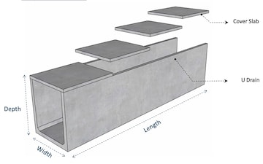
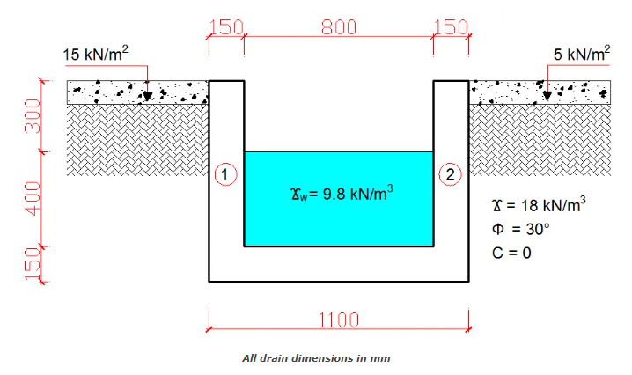

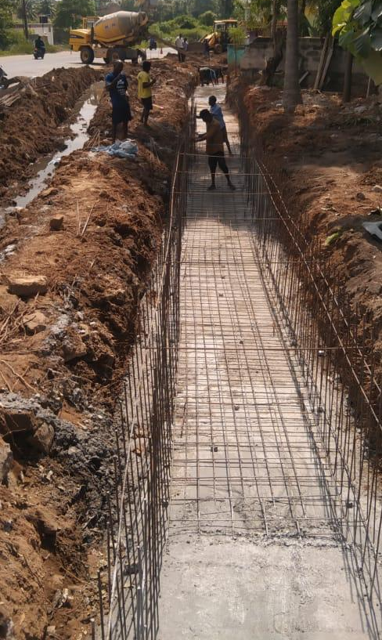
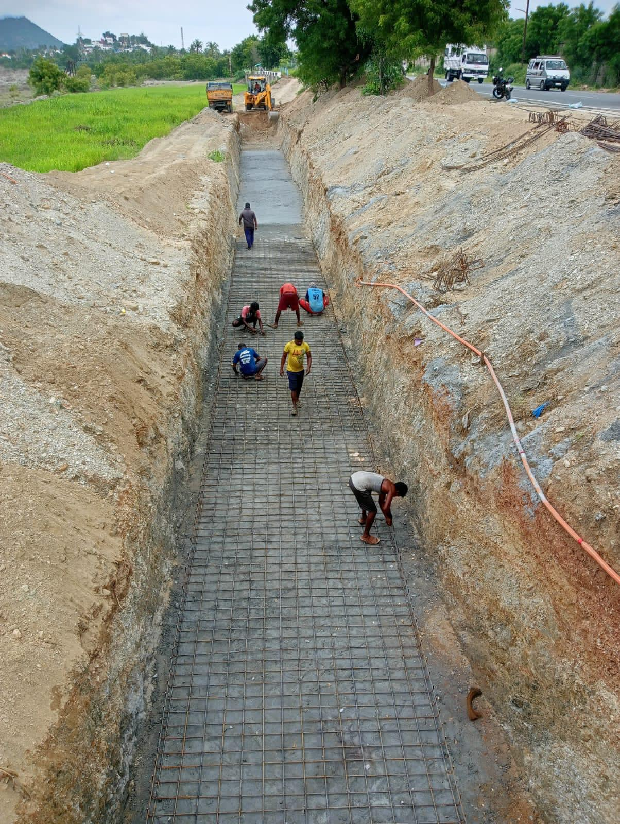

Pavement Milling & Strengthening - Estimation + Rate Analysis (IRC/MoRTH Based), India
I completed an estimation and technical study for pavement milling and strengthening works on an urban highway stretch, aligning with IRC guidance and MoRTH specifications. The scope included milling the existing bituminous layer, debris conveyance, tack coat application, and laying BC 40 mm using VG-40 based on design traffic calculations (Msa). I performed rate analysis considering equipment productivity, fuel/operating costs, labor, and logistics (municipality constraints and limited work windows). This work improved my understanding of how traffic loading, materials selection, and construction methodology directly influence estimating decisions and lifecycle performance.
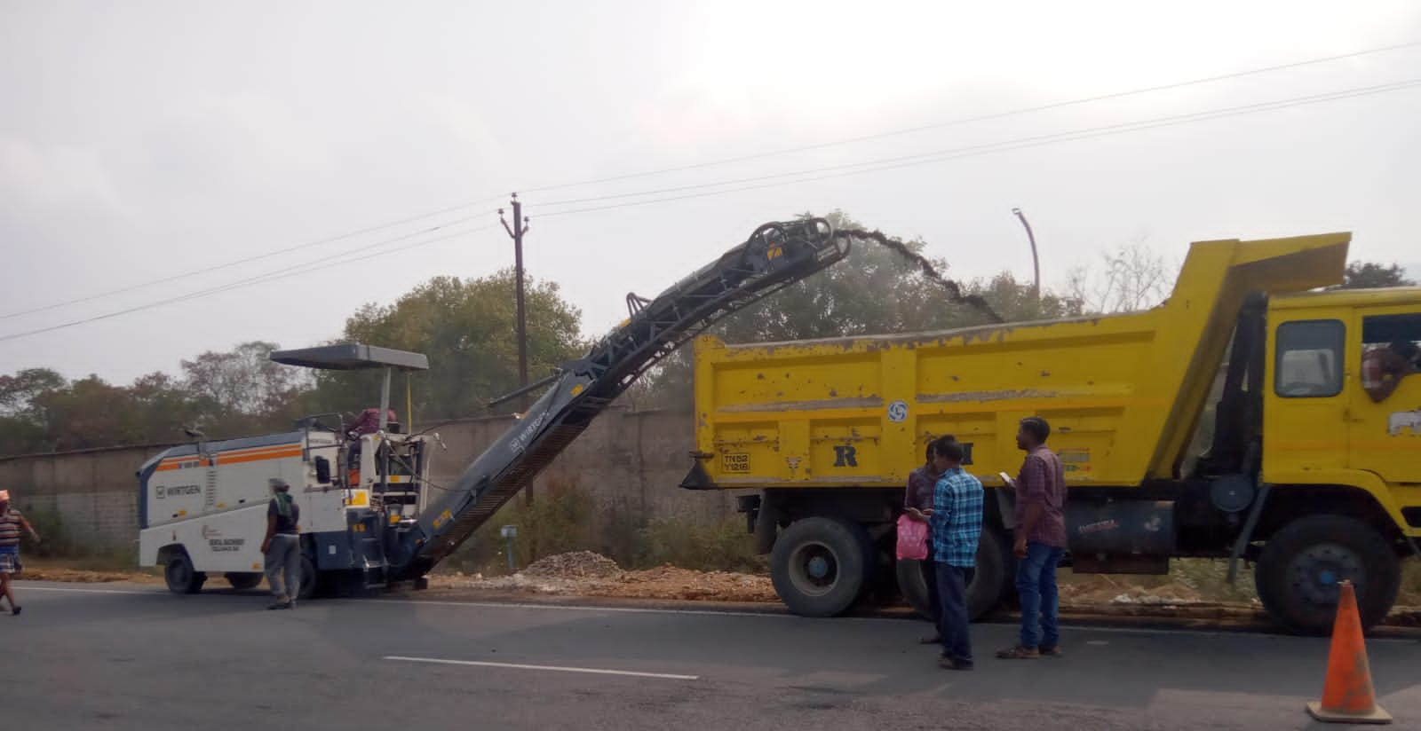

Box Culvert - Design Understanding & Estimation, India
As part of the internship, I studied the design basis of RCC box culverts and prepared estimation work for a box culvert installation at a highway chainage prone to water stagnation during monsoons. The work involved understanding loading cases and standard design provisions from the Tamil Nadu Highways manual and translating project drawings into structured quantities for earthwork, PCC, RCC components (slabs/walls), reinforcement, wing walls, backfilling, and related items. This scope strengthened my ability to connect hydraulic/structural purpose with constructible estimating, and reinforced how cross-drainage structures are planned to maintain roadway serviceability and safety.
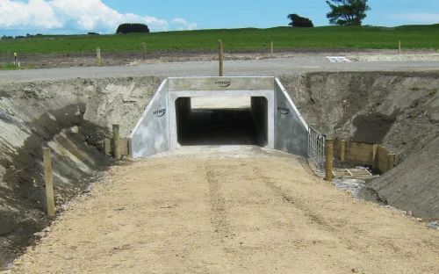

Full Report: “View Full Internship Report (PDF)” (hyperlink)

Smart India Hackathon 2023 - C&D Waste Management Platform (Clean & Green Technology)
Problem Statement ID: 1513 | Client: Ministry of Housing and Urban Affairs, Govt. of India
As part of Smart India Hackathon 2023, my team developed a sustainable, tech-enabled solution for effective management of Construction and Demolition (C&D) waste, addressing one of India’s most pressing urban infrastructure challenges.
Our solution combined engineering innovation with digital monitoring by proposing the reuse of C&D concrete waste through recycled coarse aggregates (RCA) in Self-Compacting Concrete (SCC), supported by a centralized intelligent monitoring platform. We studied advanced mix design concepts such as the Equivalent Mortar Volume (EMV) method, which improves the mechanical performance and durability of SCC using recycled aggregates, while reducing resource depletion and landfill burden.
To ensure real-world applicability, we designed a centralized web-based platform that connects demolition approvals, waste generators, municipal bodies, GPS-tracked transport, recycling plants, and end-users of recycled materials. The system enables source identification, waste tracking, incentive-based compliance, and a marketplace for recycled construction products, effectively bridging the gap between waste generation, processing, and reuse.
This project strengthened my skills in sustainable construction practices, circular economy thinking, stakeholder-driven system design, and technology-enabled infrastructure solutions, while aligning environmental responsibility with economic feasibility.

Skills & Tools Demonstrated
- Sustainable construction & circular economy concepts
- C&D waste management strategy
- Concrete technology (RCA, SCC, EMV approach)
- System & platform-level problem solving
- Policy-aware infrastructure innovation
- Team-based national-level problem solving (SIH)

Residential Building Project - End-to-End Project Management (India)
This project represents a complete residential construction lifecycle, where I was involved from initial client discussions through construction execution and near completion. The project began with understanding the client’s functional requirements, budget expectations, and spatial preferences, which were translated into a practical residential layout and construction plan.
I coordinated the design development, reviewed drawings for constructability, and supported material selection aligned with cost, durability, and local availability. My role extended into material procurement planning, vendor coordination, and scheduling deliveries to match site progress and avoid delays or excess inventory.
During construction, I was actively involved in on-site execution supervision, monitoring work quality, sequencing activities, resolving site-level issues, and coordinating between trades. Regular progress tracking and client communication ensured alignment on scope, timelines, and expectations.
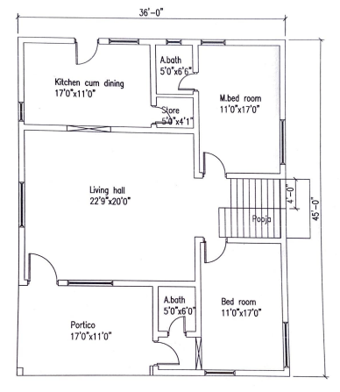
This project strengthened my hands-on understanding of residential project management, including client coordination, procurement control, site supervision, and execution-focused decision-making-experience that closely mirrors real-world construction management responsibilities.

