Fischell Band Center - Preconstruction & General Contracting Project
| Cornell University | Ithaca, New York, United States |

1. Project Overview

Project Name: Fischell Band Center – Marching Band Practice Facility
Client: Cornell University
Location: Ithaca, NY
Building Area: 4,625 Gross Square Feet
Project Type: Institutional / Educational Facility
Delivery Method: Preconstruction & General Contracting (RFP-based)
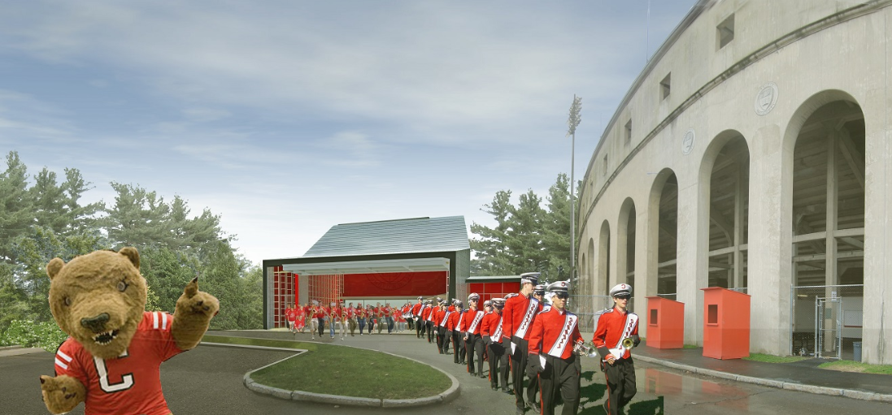
The Fischell Band Center project involved developing a complete General Contractor proposal for a new institutional facility on Cornell University’s campus. The project simulated a real-world GC pursuit process, requiring teams to prepare a coordinated cost estimate, project schedule, staffing plan, value engineering proposals, and risk assessment under defined deadlines and formal submission requirements.
The project site presented several constraints, including steep topography, limited staging space, winter construction conditions, and adjacency to active campus pedestrian and athletic zones. These constraints required careful consideration of constructability, sequencing, and logistics during preconstruction planning.

2. Project Context & RFP Requirements
Cornell University issued a formal Request for Proposal (RFP) inviting General Contractors to provide preconstruction and construction services. Proposals were evaluated equally across four categories:
- Written Proposal
- Project Schedule
- Cost Estimate
- Oral Presentation
Teams were required to work from design-level drawings and specifications, submit Requests for Information (RFIs) through a formal process, and incorporate feedback into revised cost and schedule submissions.
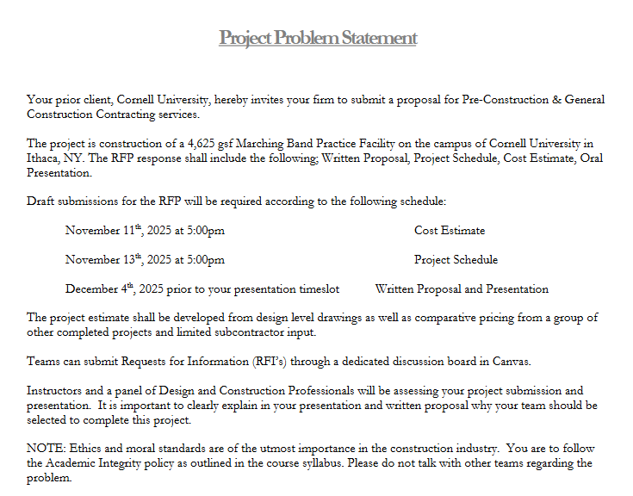This structure closely mirrored professional GC procurement processes for institutional projects, emphasizing clarity, coordination, and ethical decision-making.

3. My Role & Responsibilities
As a member of the project team, I contributed across multiple preconstruction functions, supporting the integration of cost, schedule, staffing, and risk into a cohesive proposal.
My responsibilities included:
- Performing quantity take-offs using design drawings
- Supporting CSI-based cost estimate development using subcontractor pricing
- Reviewing subcontractor scope inclusions, exclusions, and bid alignment
- Assisting with schedule logic review and sequencing analysis
- Contributing to staffing plan development by project phase
- Supporting value engineering evaluations and risk register preparation
- Assisting with RFIs and written proposal narratives

4. Cost Estimating & Bidding Approach
The project cost estimate was developed from design-level drawings and specifications using a detailed take-off methodology. Quantities were measured using Bluebeam and organized into standardized estimate worksheets structured by CSI divisions.
Subcontractor quotes were incorporated for major trade scopes, while remaining work was priced using unit-cost references consistent with U.S. construction estimating practices. Bid analysis focused on:
- Scope completeness and compliance with drawings and specifications
- Identification of exclusions and potential scope gaps
- Cost-versus-risk trade-offs among competing subcontractor proposals
The final GMP structure included direct construction costs, general conditions, contractor contingency, escalation, insurance, bonding, and contractor fee. The estimate was refined following interim feedback to improve accuracy, clarity, and risk coverage.
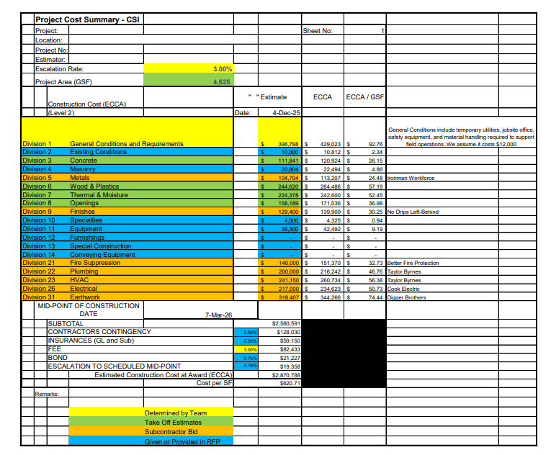Estimate Summary Lump Sum

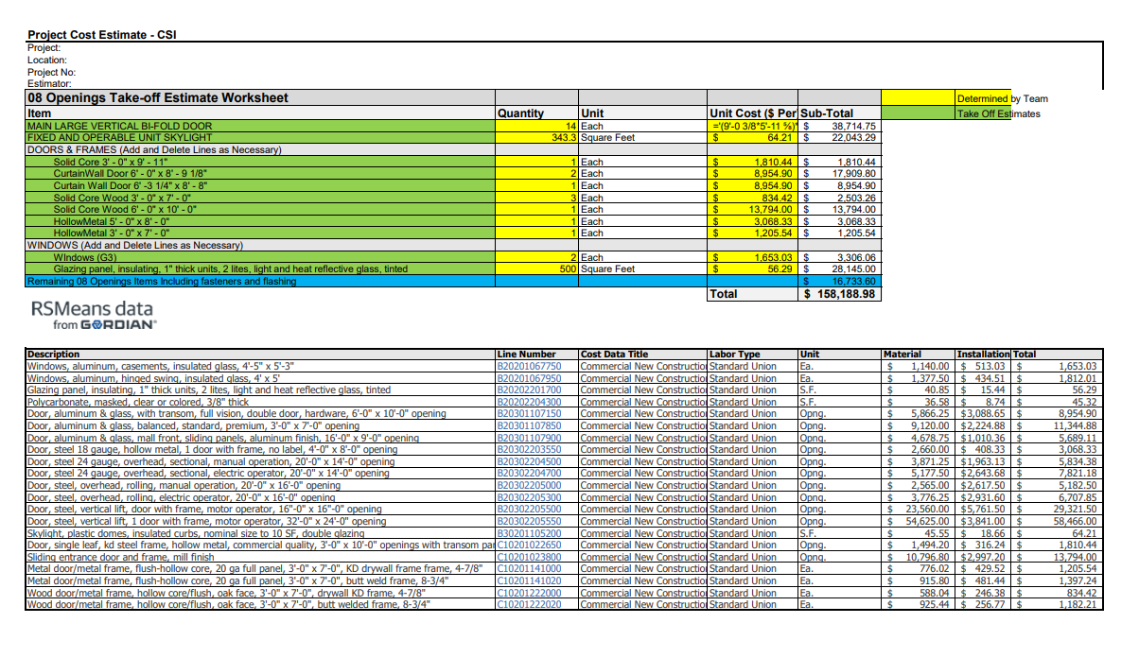
Opening Take-off Estimate

5. Project Scheduling Approach
A CPM-based project schedule was developed to reflect realistic construction sequencing for an institutional facility. The schedule accounted for:
- Site work and foundation sequencing under winter conditions
- Structural framing and building envelope coordination
- MEP rough-in sequencing and inspection requirements
- Interior finishes, testing, and closeout activities
Schedule logic emphasized constructability, trade coordination, and inspection-driven progress rather than aggressive compression. The schedule was reviewed and refined to align with cost assumptions, staffing levels, and site constraints.
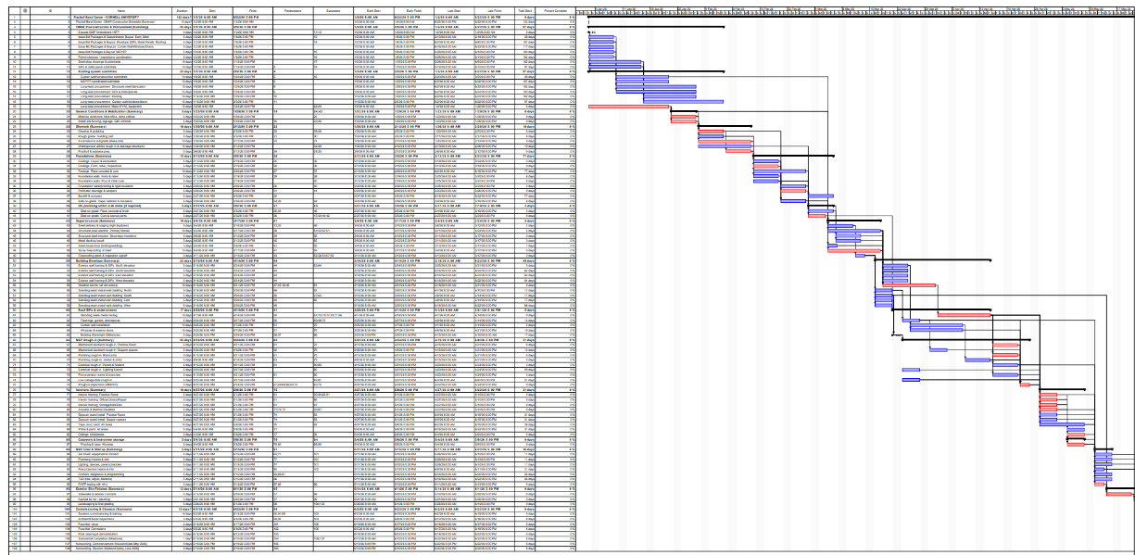
Gantt chart and project scheduling
6. Staffing Plan & Project Management Strategy
A construction staffing plan was developed to align personnel resources with the project’s scale, duration, and complexity. Staffing levels were structured by phase to balance effective project oversight with control of general conditions costs.
Key roles included:
- Project Manager
- Superintendent
- Project Engineer support
- Safety oversight
The staffing strategy emphasized clear role definition, communication flow, and proactive issue management to support quality, safety, and schedule performance.

7. Value Engineering Analysis
Value engineering options were evaluated to reduce project cost while maintaining performance, safety, and design intent. VE proposals focused on:
- Material substitutions consistent with specifications and codes
- Constructability improvements to reduce labor and rework
- Sequencing efficiencies to improve productivity
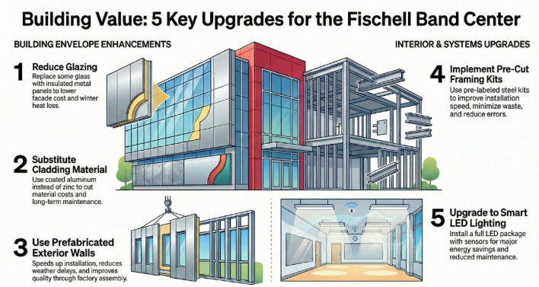
Each VE option was evaluated for cost impact, schedule implications, and risk, and documented clearly for owner consideration.

8. Risk Management & Risk Register
A project risk register was developed to identify, assess, and manage potential risks across cost, schedule, and coordination. Key risk categories included:
- Schedule risks related to winter weather and site logistics
- Cost risks associated with scope gaps and subcontractor availability
- Coordination risks between trades and inspection sequencing
Mitigation strategies were proposed for high-probability and high-impact risks, reinforcing a proactive and risk-aware preconstruction approach.

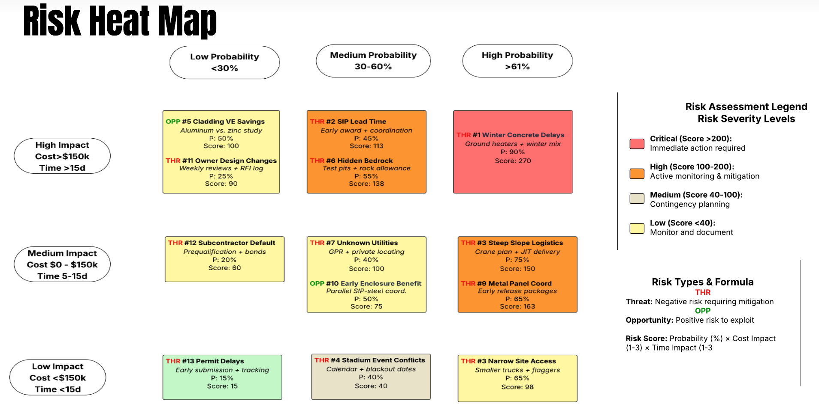

9. Outcome & Evaluation
The final submission included a coordinated GMP cost estimate, CPM schedule, staffing plan, value engineering proposals, risk register, written proposal, and oral presentation. The project was evaluated by instructors and industry professionals, with emphasis on technical accuracy, constructability, ethical standards, and clarity of communication.

10. Key Learnings & Professional Takeaways

This project strengthened my understanding of:
- How General Contractors respond to formal RFPs
- Translating drawings and specifications into structured cost estimates
- Evaluating subcontractor bids and managing scope risk
- Integrating schedule logic, staffing, and cost strategy
- Applying value engineering without compromising design intent
- Using risk registers to support proactive decision-making
The Fischell Band Center project demonstrates my ability to think and operate within a GC preconstruction environment and supports my interest in project engineering, estimating, and construction management roles.

